**Core banking systems**

Core banking systems (CBS) are essential frameworks that manage the day-to-day operations of banks, including transactions, customer accounts, loans, deposits, and other banking activities. In the U.S. banking system, these systems are crucial for the seamless operation and integration of various banking functions.

**Key Functions of Core Banking Systems**

1. **Transaction Management**: Handles all types of transactions, including deposits, withdrawals, transfers, and payments.
2. **Customer Relationship Management (CRM)**: Manages customer data, including personal details, account information, and transaction history.
3. **Loan Processing**: Manages the lifecycle of loans from application to disbursement and repayment.
4. **Deposit Management**: Handles various types of deposits, including savings, checking, and fixed deposits.
5. **General Ledger**: Maintains the bank’s financial records, ensuring accuracy and compliance with accounting standards.
6. **Risk Management**: Identifies, assesses, and manages risks associated with banking operations.
7. **Regulatory Compliance**: Ensures that the bank complies with local, state, and federal regulations.

**Popular Core Banking Systems in the U.S.**

1. **FIS (Fidelity National Information Services)**: Provides solutions like FIS Core Banking, which supports retail and commercial banking, and offers a comprehensive suite of banking services.
2. **Finastra**: Offers solutions like Fusion Banking, which provides a range of core banking functions for retail, corporate, and universal banking.
3. **Fiserv**: Known for its DNA core banking platform, which is widely used for its flexibility, scalability, and comprehensive functionality.
4. **Jack Henry & Associates**: Offers SilverLake System for commercial banks and Core Director for community banks.
5. **Oracle FLEXCUBE**: Provides a core banking solution that supports various banking functions and offers robust integration capabilities.
6. **Temenos T24**: A widely used core banking system that offers extensive functionality and flexibility for different banking needs.

**Trends in Core Banking Systems**

1. **Cloud-Based Solutions**: Increasing adoption of cloud technology to reduce costs and improve scalability and flexibility.
2. **API Integration**: Enhanced use of APIs to integrate with third-party services and improve interoperability.
3. **Real-Time Processing**: Shift towards real-time processing of transactions and data to enhance customer experience.
4. **Artificial Intelligence and Machine Learning**: Use of AI and ML for predictive analytics, risk management, and personalized banking services.
5. **Cybersecurity**: Enhanced focus on cybersecurity measures to protect sensitive financial data from breaches and attacks.

**Challenges**

1. **Legacy System Upgrades**: Many banks still operate on legacy systems that are difficult to upgrade and integrate with modern technologies.
2. **Regulatory Compliance**: Keeping up with ever-changing regulations and ensuring compliance can be challenging.
3. **Data Security**: Protecting sensitive customer data from cyber threats is a top priority and challenge for banks.
4. **Cost**: Implementing and maintaining core banking systems can be expensive, particularly for smaller banks.

**Market Share of Core Banking Systems Providers (2023)**

* FIS: 30%
* Finastra: 20%
* Fiserv: 25%
* Jack Henry: 15%
* Oracle FLEXCUBE: 5%
* Temenos T24: 5%

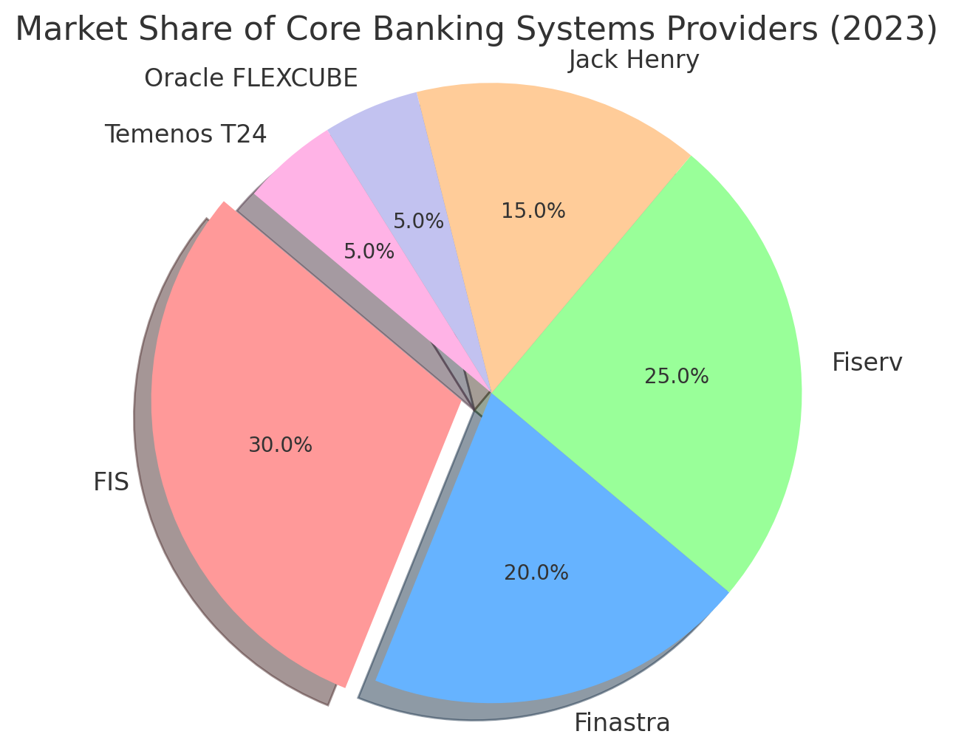

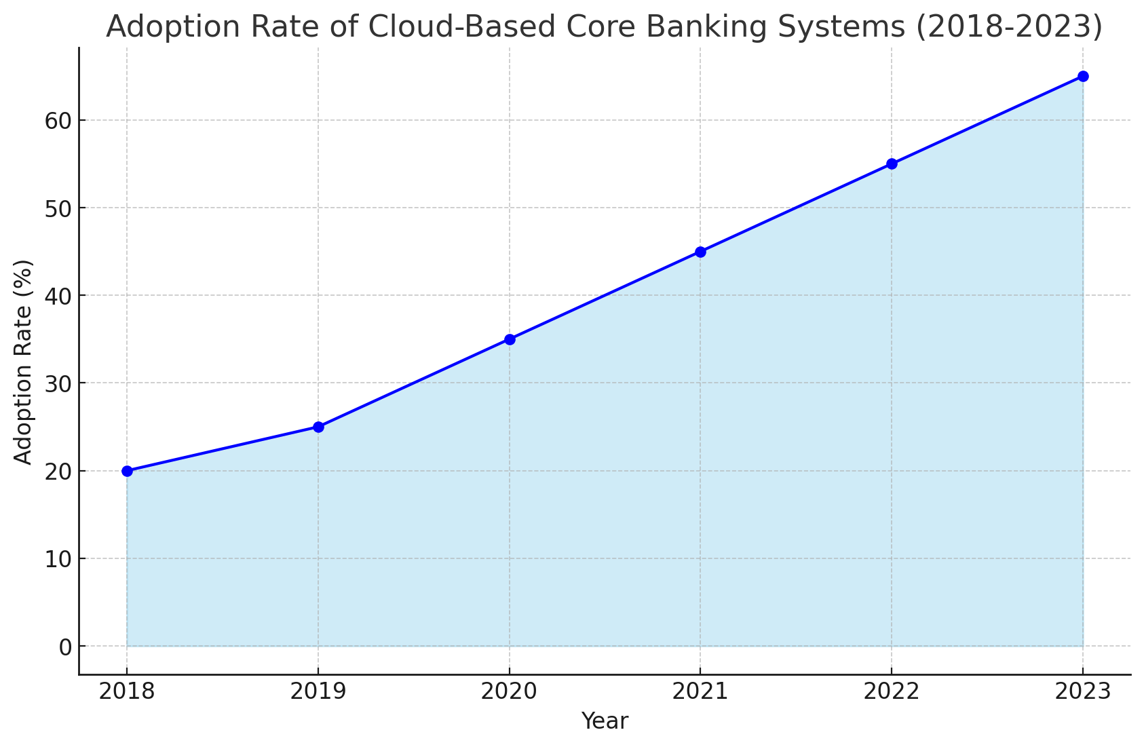

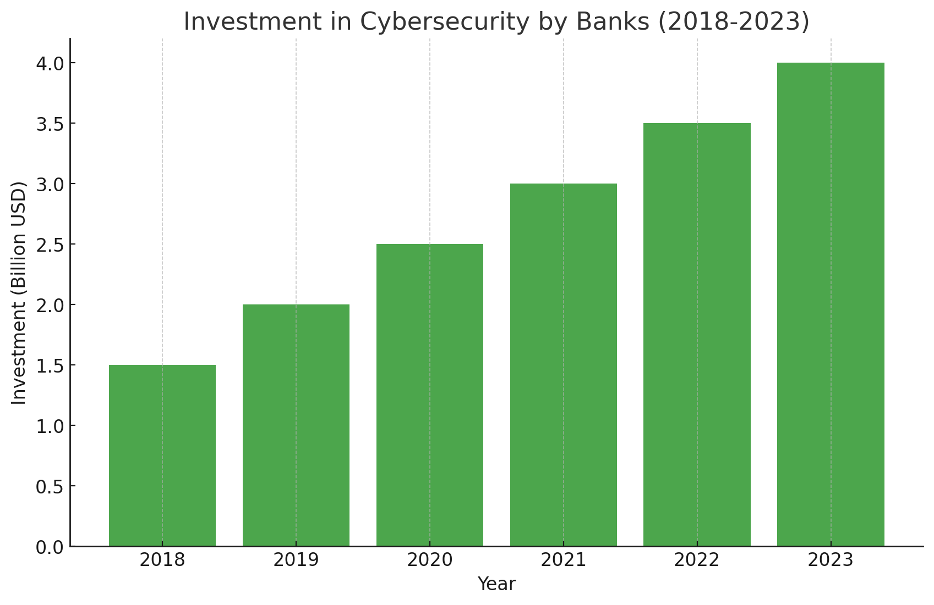

**Key changes:**

• **Shift to Cloud-Based Solutions**:

* **Insight**: The adoption of cloud-based core banking systems has increased significantly, from 20% in 2018 to 65% in 2023. This shift is driven by the need for greater scalability, cost-efficiency, and flexibility offered by cloud solutions.

• **Increase in Cybersecurity Investments**:

* **Insight**: Investments in cybersecurity have risen from 1.5 billion USD in 2018 to 4.0 billion USD in 2023. This increase reflects the growing importance of protecting sensitive financial data and systems from cyber threats.

• **Integration of AI and ML Technologies**:

* **Insight**: Investments in AI and ML technologies have increased from 0.5 billion USD in 2018 to 3.0 billion USD in 2023. These technologies are being increasingly integrated into core banking systems for enhanced data analysis, fraud detection, and personalized banking services.

• **Rising Regulatory Compliance Costs**:

* **Insight**: Regulatory compliance costs have grown from 1.0 billion USD in 2018 to 2.4 billion USD in 2023. This trend highlights the increasing complexity and cost of complying with evolving financial regulations.